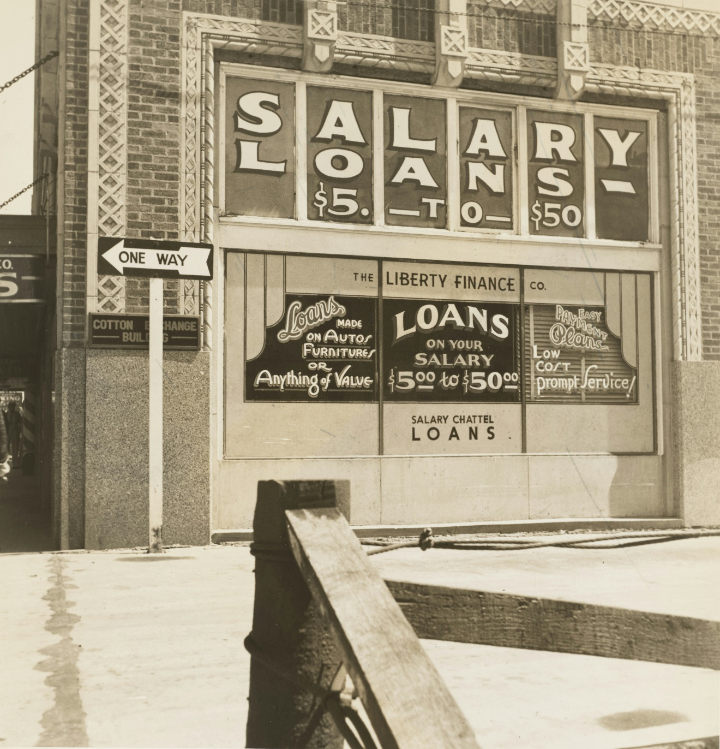

**Credit Train**

**By Omar Saad**

**1. Introduction:**

In the context of credit risk modeling, the term "credit train" refers to a training dataset used to build and train machine learning models that predict the creditworthiness of individuals or businesses. This dataset typically contains historical information about borrowers, including:

Personal or business details (e.g., income, credit history, loan amounts)

Past credit behaviors (e.g., payment history, defaults)

Financial information (e.g., assets, liabilities)

The model is trained on this dataset to learn patterns and relationships that help predict whether a borrower will default on a loan or whether they are likely to be creditworthy.

Once trained, the model can then be tested and deployed to assess the credit risk of new applicants based on their data, providing financial institutions with insights into lending decisions.

**2. Analysis Section:**

In the analysis phase of this credit risk modeling project, we will conduct an in-depth exploration of the dataset to understand key patterns and factors that influence creditworthiness. This analysis will begin with univariate and bivariate statistical analysis to identify significant trends and relationships in variables such as income, credit history, loan amount, and payment behavior. We will examine distribution patterns, correlations, and outliers to gain insights into risk factors associated with default and identify features that are likely to impact the model’s predictive accuracy. Additionally, we will visualize key findings to support the interpretation of complex data relationships and provide a solid foundation for feature engineering and model development. The analysis will inform our approach to developing a robust credit risk model, ensuring it aligns with the practical goals of assessing borrower risk effectively.

**3.Machine Learning:**

The machine learning phase of this credit risk modeling project will focus on developing and training predictive models to assess the creditworthiness of borrowers accurately. We will start by preprocessing the data, which includes handling missing values, encoding categorical variables, and scaling numerical features to ensure compatibility with our chosen algorithms. Multiple algorithms, such as Logistic Regression, Decision Trees, and Random Forests, will be explored to identify the best-performing model for our classification task. We will then use hyperparameter tuning techniques to optimize the model with the highest initial accuracy, enhancing its precision and recall in predicting loan defaults. The finalized model will undergo rigorous testing and evaluation on unseen data, using metrics such as accuracy, F1-score, and AUC to ensure its reliability in real-world applications. This approach will create a robust tool to support financial decision-making by effectively identifying and managing credit risk.

**4. Resources Required:**

* **Software**: Python, libraries like pandas, scikit-learn, seaborn, matplotlib, Streamlit
* **Hardware**: Computing resources (if needed for large datasets)
* **Data**: Car price dataset

**5. Risk Management:**

* **Data Quality Issues**: Strategies for handling missing values or outliers.
* **Model Performance**: Approaches to improve model accuracy if initial results are unsatisfactory.
* **Technical Challenges**: Contingency plans for any issues with software or hardware.

**6. Conclusion:**

This credit risk modeling project aims to provide a comprehensive, data-driven solution for evaluating borrower creditworthiness, combining advanced data analysis with predictive modeling. Through a detailed analysis of historical credit data and the development of a highly accurate machine learning model, the project will deliver insights into the factors influencing credit risk and create a reliable tool for predicting loan defaults. By implementing a rigorous approach to data processing, model selection, and evaluation, this project not only supports effective risk management but also enhances decision-making capabilities for financial institutions. The resulting model will contribute to minimizing credit losses and fostering responsible lending practices, ultimately adding value to both lenders and borrowers.

**LinkedIn:** [https://www.linkedin.com/in/omar-saad-1013a323bTop](https://www.linkedin.com/in/omar-saad-1013a323b) of Form

**Github:** https://github.com/omarsaad21

Bottom of Form